**Installation of Apache and MySQL in Ubuntu in Virtual Machine using Oracle Virtual Box**

1. Install Apache

*$ sudo apt install apache2*

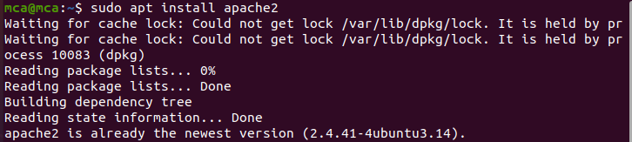

1. Start Apache

*$ sudo systemctl start apache2*

1. Check status of Apache

*$ sudo systemctl status apache2*

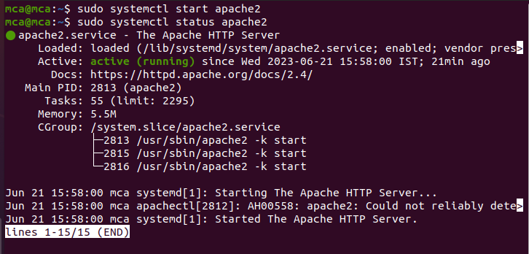

1. Check localhost

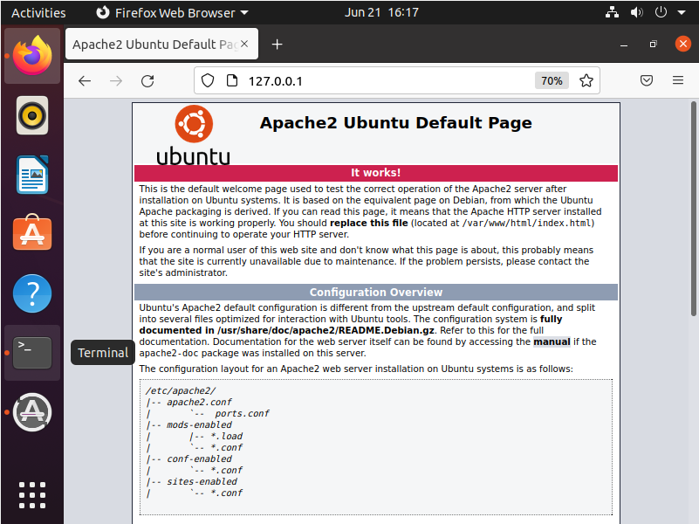

1. Install MySQL Server

*$ sudo apt install mysql-server -y*

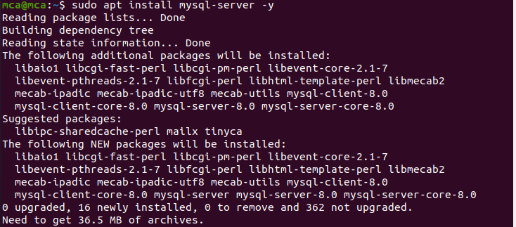

1. Start MySQL

*$ sudo systemctl start mysql*

1. Check status of MySQL

*$ sudo systemctl status mysql*

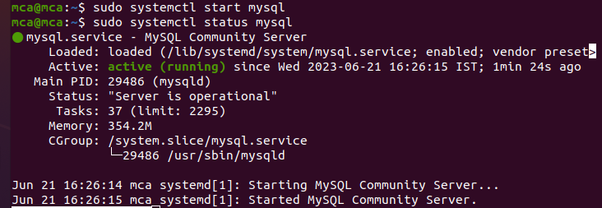

1. Enter into MySQL from CLI

*$ sudo muysql*

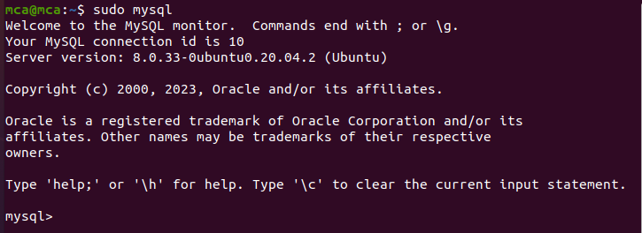

1. Create a database

*mysql> create database demo;*



1. Use database

*mysql> use demo*



1. Display all databases

*mysql> show databases;*

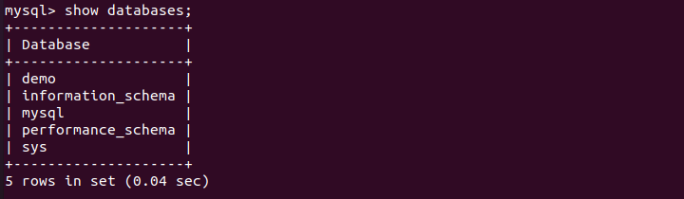

1. Create a table

*mysql> create table users (id int primary key, name varchar(10));*



1. Insert values into the table

*mysql> insert into users values (“1”, “AMAL”);*



1. Display the table

*mysql > select * from users;*

